Task 2: MulTiple linear regression Model

A real estate analyst wants to predict the median value of houses in different neighborhoods based on various property and neighborhood features. You are tasked with building a Multiple Linear Regression model that can predict housing prices using numerical predictors

CODE:

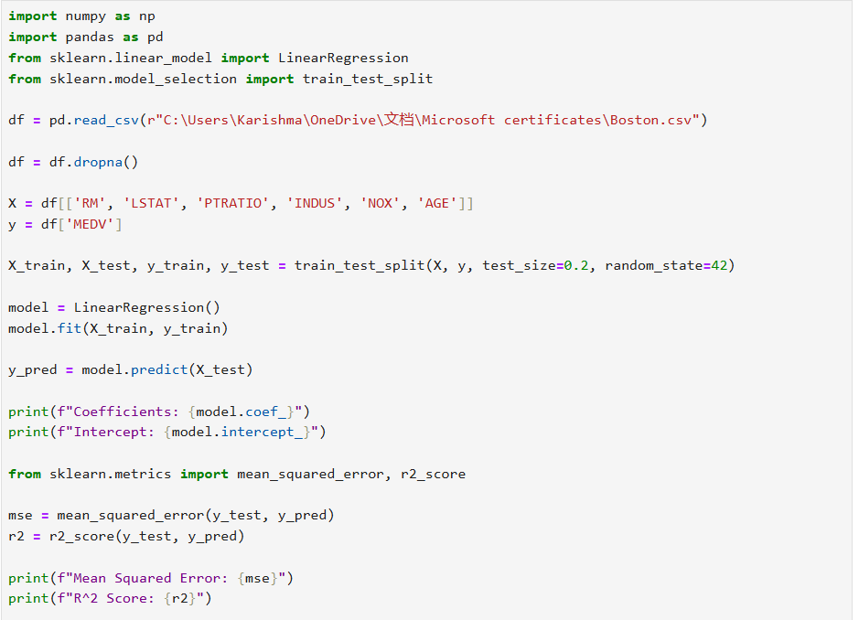
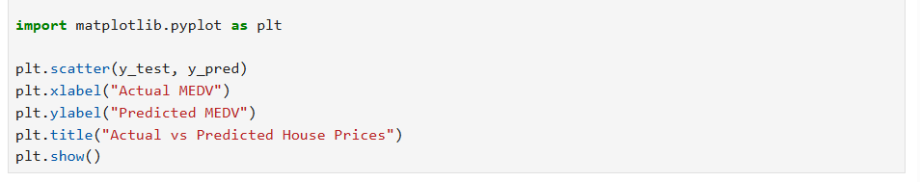

OUTPUT:

